**Faasos Case Study**

1. **Roll Metrics**
2. **How many rolls were ordered**

select count(order_id) as total_rolls_ordered

from customer_order;



1. **How many unique orders were made**

select count(distinct order_id) as unique_orders

from customer_order;



1. **How many unique customers**

select count(distinct customer_id) as unique_customers

from customer_order;



1. **How many successful orders delivered by each driver**

select driver_id, count(order_id) as order_delivered

from driver_order

where duration is not null

group by driver_id;

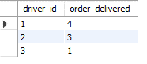

1. **How many of each type of roll was delivered**

select roll_id, count(roll_id) as num_of_each_roll_delivered

from driver_order d

inner join customer_order c

on d.order_id = c.order_id

where d.duration is not null

group by roll_id;



1. **How many veg and non-veg rolls were ordered by each customer**

select customer_id,

sum(case when roll_id = 1 then 1 else 0 end) as num_of_nonveg,

sum(case when roll_id <> 1 then 1 else 0 end) as num_of_veg

from customer_order

group by customer_id;

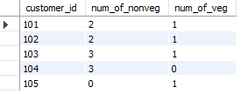

1. **Maximum number of rolls delivered in a single order**

select c.order_id, count(c.order_id) as max_rolls_per_order

from customer_order c

inner join driver_order d

on c.order_id = d.order_id

where d.duration is not null

group by c.order_id

order by 2 desc

limit 1;



1. **For each customer, how many delivered rolls had at least 1 change and how many had no changes**

with cte as

(select

case when not_include_items is null or not_include_items = '' then 0 else not_include_items end as exclude_items,

case when extra_items_included is null or extra_items_included = '' or extra_items_included = 'NaN' then 0

else extra_items_included end as add_items, c.*

from customer_order c

inner join driver_order d

on c.order_id = d.order_id

where d.duration is not null)

select customer_id,

sum(case when exclude_items > 0 or add_items > 0 then 1 else 0 end) as changes_in_order,

sum(case when exclude_items = 0 and add_items = 0 then 1 else 0 end) as no_changes_in_order

from cte

group by customer_id;

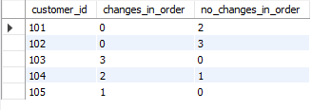

1. **How many rolls were delivered that had both exclusions and extras**

with cte as

(select case when not_include_items is null or not_include_items = '' then 0 else not_include_items end as exclude_items,

case when extra_items_included is null or extra_items_included = '' or extra_items_included = 'NaN' then 0

else extra_items_included end as add_items, c.*

from customer_order c

inner join driver_order d

on c.order_id = d.order_id

where d.duration is not null)

select order_id, count(order_id) order_with_both_changes

from cte

where exclude_items > 0 and add_items > 0

group by order_id;



1. **What was the total number of rolls ordered at each hour of the day**

with cte1 as

(select *, hour(order_date) as hour_of_day,

hour(addtime(order_date, "01:00:00")) as hour_plus_one

from customer_order),

cte2 as

(select *, concat(hour_of_day, "-", hour_one) as hour_interval

from cte1)

select hour_interval, count(roll_id) as order_per_hour

from cte2

group by hour_interval

order by 1;

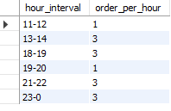

1. **what was the number of orders for each day of the week**

with cte as

(select *, dayname(order_date) as day_of_week

from customer_order)

select day_of_week, count(order_id) orders_per_day

from cte

group by day_of_week;

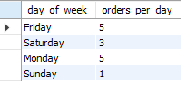

1. **Driver and Customer Experience Metrics**
2. **What was the average time (in minutes) it took each driver to arrive at the Faasos outlet to pick up the order**

with cte1 as

(select c.*, d.driver_id, d.pickup_time, timestampdiff(minute, order_date, pickup_time) as time_to_pickup

from customer_order c

inner join driver_order d

on c.order_id = d.order_id

where d.pickup_time is not null),

cte2 as

(select *,

row_number() over(partition by order_id order by time_to_pickup) as rnum

from cte1)

select driver_id, round(avg(time_to_pickup),0) as avg_time_to_pickup

from cte2

where rnum = 1

group by driver_id;

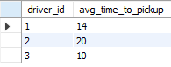

1. **Is there any relation between the number of rolls and how long the order takes to prepare**

with cte as

(select c.*, d.driver_id, d.pickup_time, timestampdiff(minute, order_date, pickup_time) as time_to_prepare_order

from customer_order c

inner join driver_order d

on c.order_id = d.order_id

where d.pickup_time is not null)

select order_id, count(order_id) total_rolls_per_order, time_to_prepare_each_order

from cte

group by order_id**;**

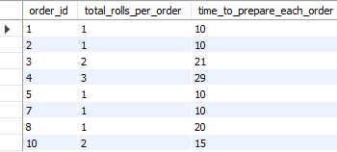

1. **What was the average distance travelled for each customer**

with cte as

(select c.*, trim(replace(d.distance, 'km', '')) distance_travelled

from customer_order c

inner join driver_order d

on c.order_id = d.order_id

where d.pickup_time is not null)

select customer_id, round(avg(distance_travelled), 2) avg_distance_travelled

from cte

group by customer_id;

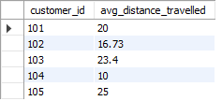

1. **What was the difference between the longest and the shortest times for all orders**

with cte as

(select *, left(duration,2) time_taken_to_deliver

from driver_order

where duration is not null)

select max(time_taken_to_deliver) - min(time_taken_to_deliver) range_of_delivery_time

from cte;



1. **What was the average speed for each driver for each delivery is there any trend for these values**

with cte1 as

(select *, trim(replace(distance, 'km', '')) distance_travelled,

left(duration,2) time_taken_to_deliver

from driver_order

where duration is not null),

cte2 as

(select *, distance_travelled / time_taken_to_deliver as speed_of_delivery

from cte1)

select c2.order_id, driver_id, round(avg(speed_of_delivery),2) as avg_speed_per_delivery,

count(c.order_id) count_per_order

from cte2 as c2

inner join customer_order c

on c2.order_id = c.order_id

group by c2.order_id, driver_id;

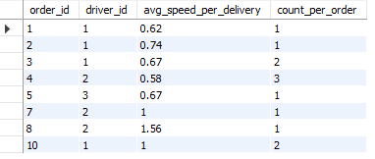

1. **What is the successful delivery percentage for each driver**

select driver_id,

round(sum(case when cancellation is null or cancellation = 'NaN' or cancellation = '' then 1 else 0 end)*100.0 / count(*),0) as completion_percent,

round(sum(case when cancellation in ('Cancellation', 'Customer Cancellation') then 1 else 0 end)*100.0 / count(*),0) as cancellation_percent

from driver_order

group by driver_id;

